Textbooks:

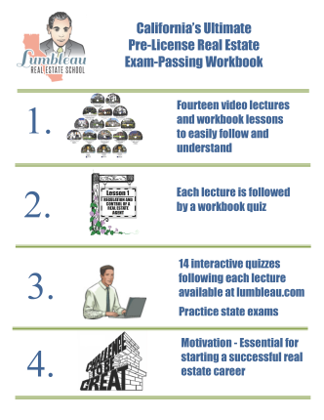

**Lumbleau Exam Passing Workbook (2014 Edition)**

**To be used with the legendary Lumbleau Exam Passing Online Course. This workbook contains 14 lessons followed by quizzes on each subject. Over 1,000 sample test questions designed to prepare the student for the California salesperson and broker test.**

[Download Table of Contents (PDF)](http://www.etcbooks.com/pdf/principles_13_toc.pdf)

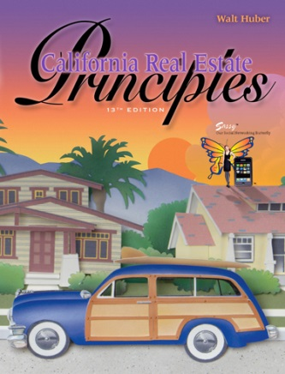

**California Real Estate Principles - 13th ed.**

An ideal introductory text for beginning real estate students and an excellent study guide for those taking the state license exam.

[Download Table of Contents (PDF)](http://www.etcbooks.com/pdf/principles_13_toc.pdf)

ISBN 978-0-916772-09-3

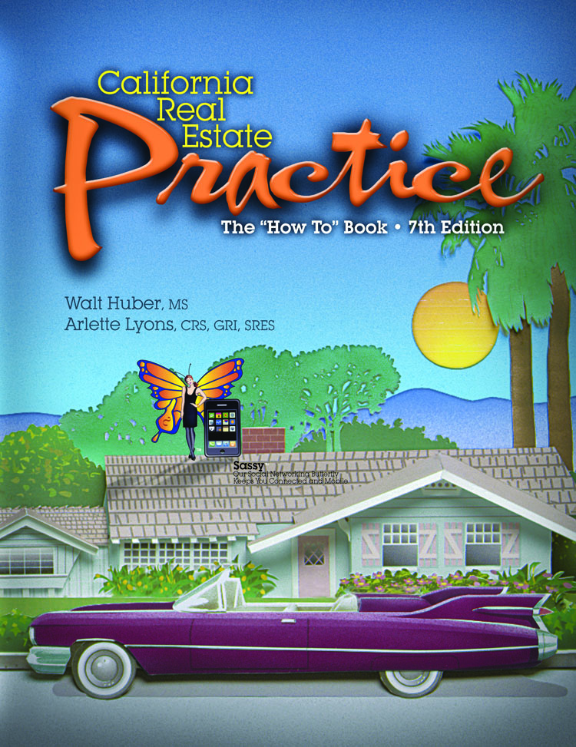

**California Real Estate Practice 7th Ed.**

Provides the person interested in a career as a real estate broker with basic information pertinent to the various aspects of real estate practice.

[Download Table of Contents (PDF)](http://www.etcbooks.com/pdf/practice_7th_toc.pdf)

ISBN 978-0-916772-86-4